

**UNIVERSITY OF PETROLEUM & ENERGY STUDIES**

**College of Engineering Studies Dehradun**

**LAB FILE**

**Experiment 1**

Programme : B. Tech in Computer Science and Engineering with Specialization in DevOps

Course : Continuous Integration & Continuous Deployment Lab

No. of credits : 1

Semester : V

Session : July-December 2020

Batch : 2018-2022

Faculty : Dr. Hitesh Kumar Sharma

Submitted By:

Ingit Singhal

Sap id: 50056426

Roll No : R171218048

**Lab Experiment 1**

**Installation of Jenkins and execution of a basic job on Jenkins.**

**Screenshots**

For running Jenkins, JDK/JRE 8 to JDK/JRE 11 is required.

The steps to be followed are:

1. Go to the website <https://www.jenkins.io/download/> and download the Generic Java Package for Jenkins.

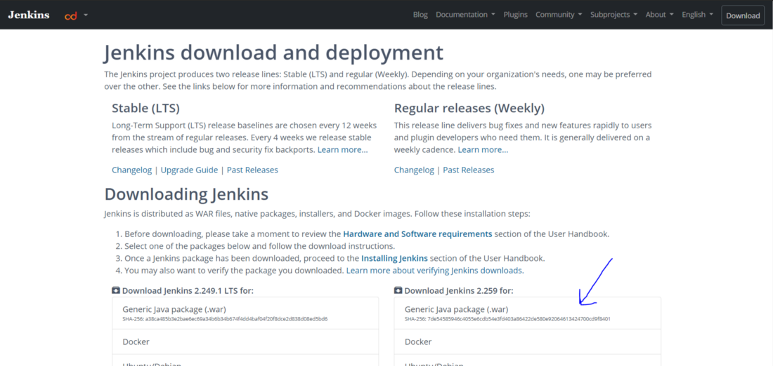

2. The above step will download a war file. Place the downloaded file at a desired location on the PC.

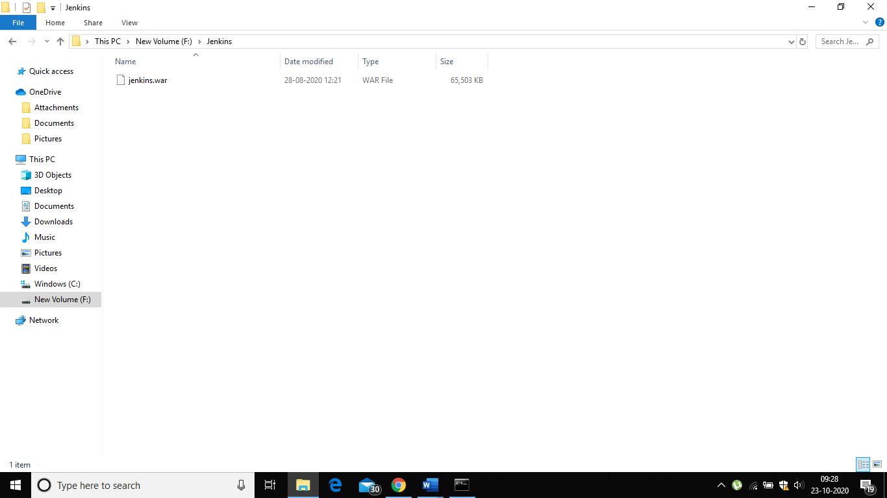

Run this command after entering the folder where the jenkins.war file is present.

